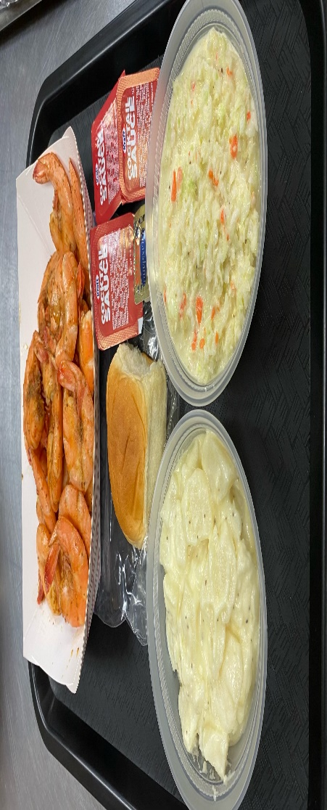
Reese Auxiliary Drive-thru
Steamed Shrimp Platters

1lb. Steamed Shrimp 21-25 ct., Homemade Potato Salad, Homemade Coleslaw and a Roll

$20.00 a platter
Saturday, October 22, 2022
Time - 3:00pm – 6:00pm or until sold out
Cash Only

Preorders are STRONGLY encouraged. Place your preorders by calling Wanda at
410-857-0309 between the hours of 10:00 am to 7:00 pm. If no answer, please leave a message.
Please stay in your car, we will deliver it to you.

Thank you for your continued support and we hope that you’ll be able to join us for this delicious dinner!

Location: Reese Volunteer Fire Company
1745 Baltimore Blvd Westminster, Md 21157

